**ANALYSIS USING MySQL**

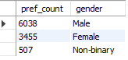**Who prefers energy drink more? (male/female/non-binary?)**

SELECT COUNT (respondent_id) as pref_count, gender

from dim_repondents

group by 2

order by 1 desc;

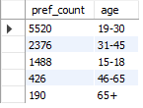**Which age group prefers energy drinks more?**

SELECT COUNT (respondent_id) as pref_count, age

from dim_repondents

group by 2

order by 1 desc;

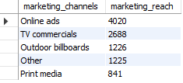**Which type of marketing reaches the most Youth (15-30)?**

SELECT f.marketing_channels,

count(age) as marketing_reach

from dim_repondents r

join fact_survey_responses f on r.Respondent_ID = f.Respondent_ID

where r.age = '15-18' or '19-30'

group by 1

order by 2 desc;

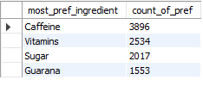**What are the preferred ingredients of energy drinks among respondents?**

SELECT Ingredients_expected as most_pref_ingredient,

count(respondent_id) as count_of_pref

from fact_survey_responses

group by 1

order by 2 desc;

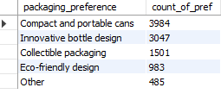**What packaging preferences do respondents have for energy drinks?**

select packaging_preference,

count(respondent_id) as count_of_pref

from fact_survey_responses

group by 1

order by 2 desc;

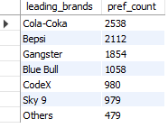**Who are the current market leaders?**

SELECT current_brands as leading_brands,

count(respondent_id) as pref_count

from fact_survey_responses

group by 1

order by 2 desc;

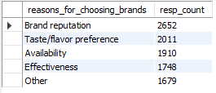**What are the primary reasons consumers prefer those brands over ours?**

SELECT (reasons_for_choosing_brands),

count(respondent_id) as resp_count

from fact_survey_responses

group by 1

order by 2 desc;

**What do people think about our brand? (overall rating)**

1. 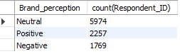**Brand perception**

SELECT Brand_perception, count (Respondent_ID)

FROM fact_survey_responses

group by 1;

1. **Heard before**

SELECT Heard_before, count(Respondent_ID)

FROM fact_survey_responses

group by 1;

1. **Tried before**

SELECT Tried_before, count(Respondent_ID)

FROM fact_survey_responses

group by 1;

1. **Average rating**

SELECT avg(Taste_experience)

FROM fact_survey_responses

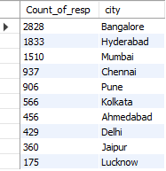**Which cities do we need to focus more on?**

select count(respondent_ID) as Count_of_resp, c.city

from dim_repondents r

join dim_cities c on r.City_ID=c.City_ID

group by c.City

order by 1 desc;

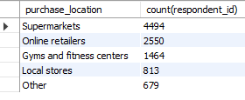**Where do respondents prefer to purchase energy drinks?**

select purchase_location, count(respondent_id)

from fact_survey_responses

group by 1

order by 2 desc;

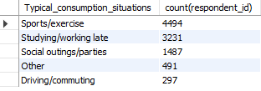**What are the typical consumption situations for energy drinks among respondents?**

select Typical_consumption_situation, count(respondent_id)

from fact_survey_responses

group by 1

order by 2 desc;

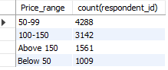**What factors influence respondents' purchase decisions, such as price range and limited-edition packaging?**

select Price_range, count(respondent_id)

from fact_survey_responses

group by 1

order by 2 desc;

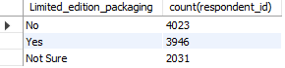select Limited_edition_packaging, count(respondent_id)

from fact_survey_responses

group by 1

order by 2 desc;

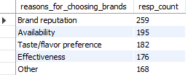**Which area of business should we focus more on our product development? (Branding/taste/availability)**

SELECT (reasons_for_choosing_brands),

count(Response_ID) as resp_count

from fact_survey_responses

where Current_brands = 'CodeX'

group by 1

order by 2 desc;